EXPERIMENT 4

ROLL NO: 230701320 NAME: Sivaruhith S
Create a prototype with familiar and unfamiliar navigation elements. Evaluate ease of use with different user groups using proto.io
Screen 1:
Home page:
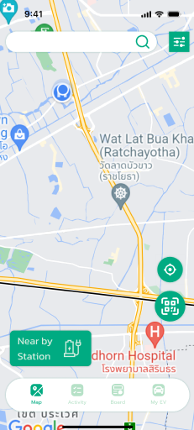
Familiar Icons:
- Hamburger Menu (☰) - Top Left:
  - A common icon representing a collapsible navigation menu.
  - Clicking it usually opens a sidebar with options like Home, Settings, and Profile.
- Search Icon (🔍) - Below the Heading:
  - A widely recognized icon used for searching within the app.
  - Clicking it typically opens a search bar where users can type queries.
- Three-Dot Menu (⋮) - Near "Trending Styles":
  - Represents more options or actions related to the section.
  - Often used for settings, sorting, or additional functionalities.
Possibly Unfamiliar Icons:
- Explore Button:
  - This is not an icon but a button that might lead to more details or booking options for the resort.
  - It’s common in travel and e-commerce apps but might be designed differently.
- Time (08:04) - Top Right Corner:
  - This is a standard phone status display but may also indicate a feature like a time-based greeting or notification.

Screen 2:
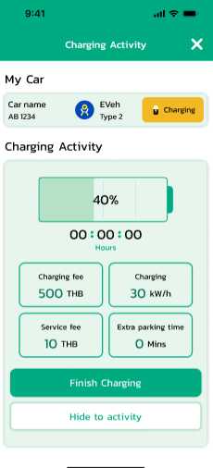

Screen 3:
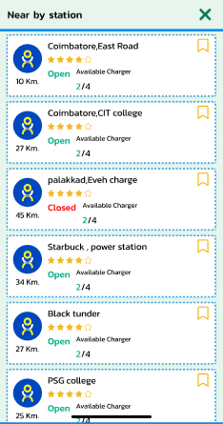
Familiar Icons:
- Back Arrow (←) - Top Left Corner:
  - A widely recognized icon used for navigation.
  - Clicking it will likely take the user back to the previous screen.

Screen 4:
QR Scanning page
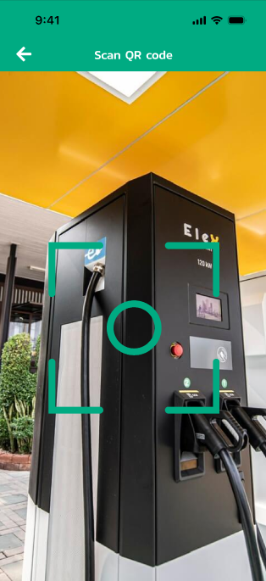
:

Familiar Icons:
- Back Arrow (←) - Top Left Corner:
  - A widely recognized navigation icon.
  - Clicking it will likely take the user back to the previous screen.
- Time Display (08:07) - Top Right Corner:
  - A standard phone status indicator that shows the current time.
Screen 5:
Profile page:
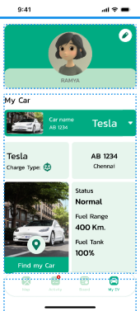

Familiar Icons:
- Profile Icon (Circle Placeholder - Top Left):
  - Represents the user's profile picture or avatar.
  - Clicking it may allow users to edit their profile or view account details.
- Transaction Icon (💳 or similar) - Next to "Transaction":
  - Commonly used for payments, purchases, or financial records.
  - Clicking it likely opens transaction history.
- Coupons Icon (🎟️ or Tag Symbol) - Next to "Coupons":
  - Represents discounts, offers, or vouchers.
  - Clicking it may show available coupons for the user.
- Heart Icon (💙) - Next to "Favourite":
  - A universally recognized icon for saved or liked items.
  - Clicking it will likely show favorite places, hotels, or deals.
- Logout Icon (⏻ or ↩) - Next to "Log out":
  - Commonly represents signing out of an account.
  - Clicking it will log the user out of the app.

Prototype Link:
https://sivaruhith1.proto.io/editor/index.cfm?id=c182b929-3e7a-45de-a7c7-a63f2d8a4060

